Experiment:9 Date:25/07/2026

The Travelling Salesman Problem (TSP) Using Branch and Bound Algorithm

Aim
To develop a Python program to solve the Travelling Salesman Problem (TSP) using the Branch and Bound Algorithm and determine the minimum cost path that visits every city exactly once and returns to the starting city.

Algorithm (Branch and Bound)
- Read the number of cities.
- Read the cost matrix from the user.
- Start from City 0.
- Generate all possible routes.
- Calculate the total cost of each route.
- Compare the costs and keep the minimum cost route.
- Display the optimal path.
- Display the minimum travelling cost.

Program:
from itertools import permutations

n = int(input("Enter Number of Cities: "))
cost = []
print("Enter Cost Matrix:")
for i in range(n):
row = list(map(int, input().split()))
cost.append(row)
cities = list(range(1, n))
min_cost = float('inf')
best_path = []
for path in permutations(cities):
current = [0] + list(path) + [0]
total = 0
for i in range(len(current)-1):
total += cost[current[i]][current[i+1]]
if total < min_cost:
min_cost = total
best_path = current
print("\nOptimal Path")
step = 1
for city in best_path:
print(f"Step {step} : City {city}")
step += 1
print("\nMinimum Cost =", min_cost)

OUTPUT:

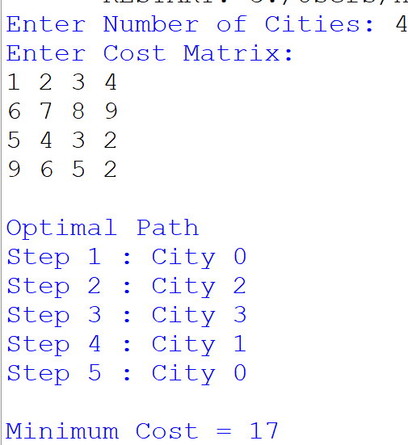
Result:
Thus, the Travelling Salesman Problem (TSP) was solved successfully using the Branch and Bound Algorithm, and the minimum cost path was obtained.

